# **Coding Challenge 1**

1. Provide a SQL script that initializes the database for the Pet Adoption Platform "PetPals".

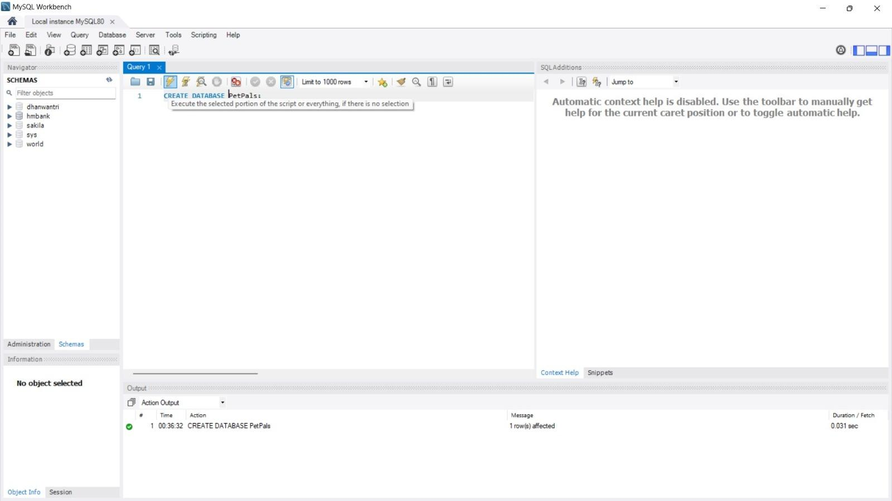

1. Create tables for pets, shelters, donations, adoption events, and participants.

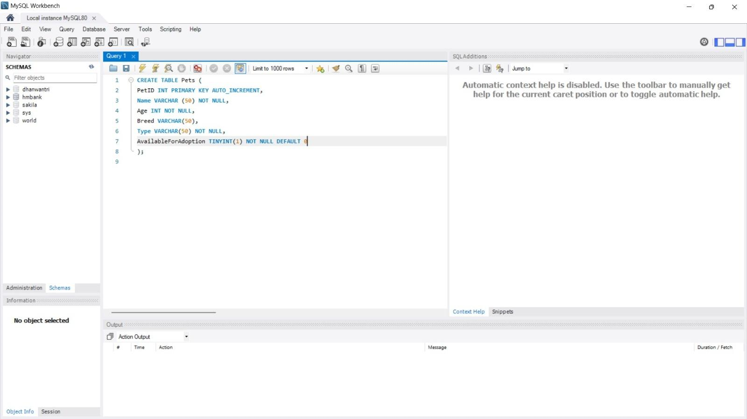

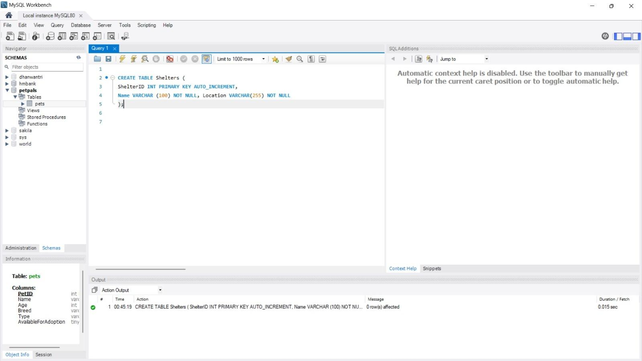

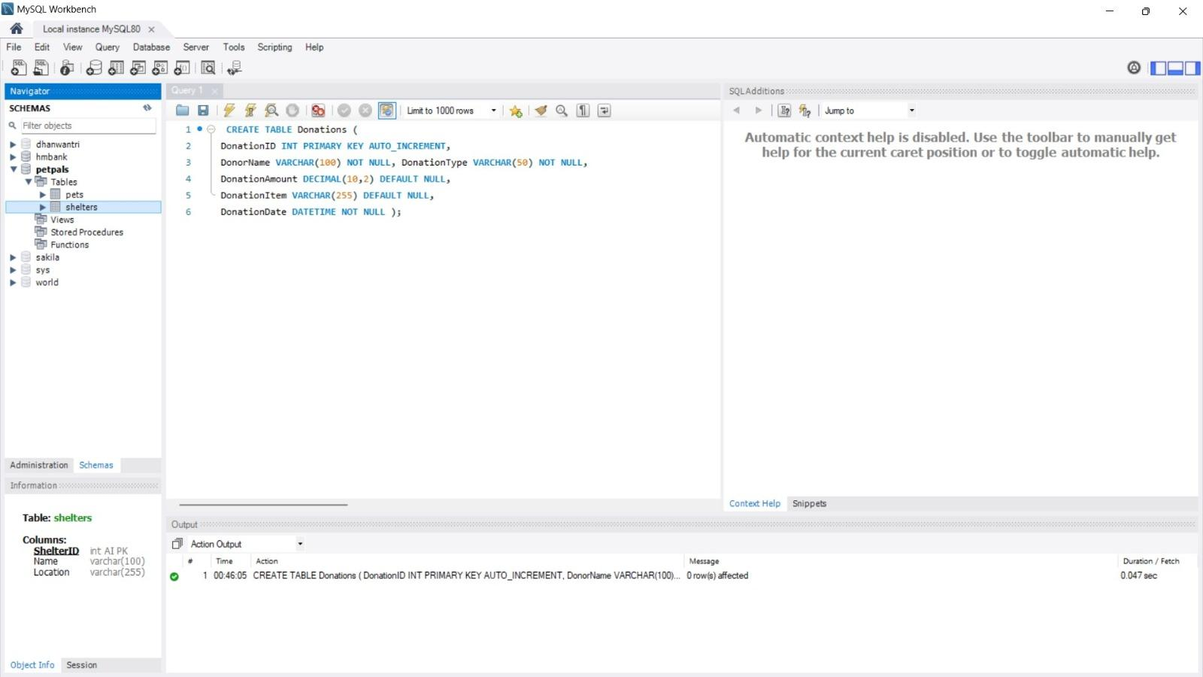

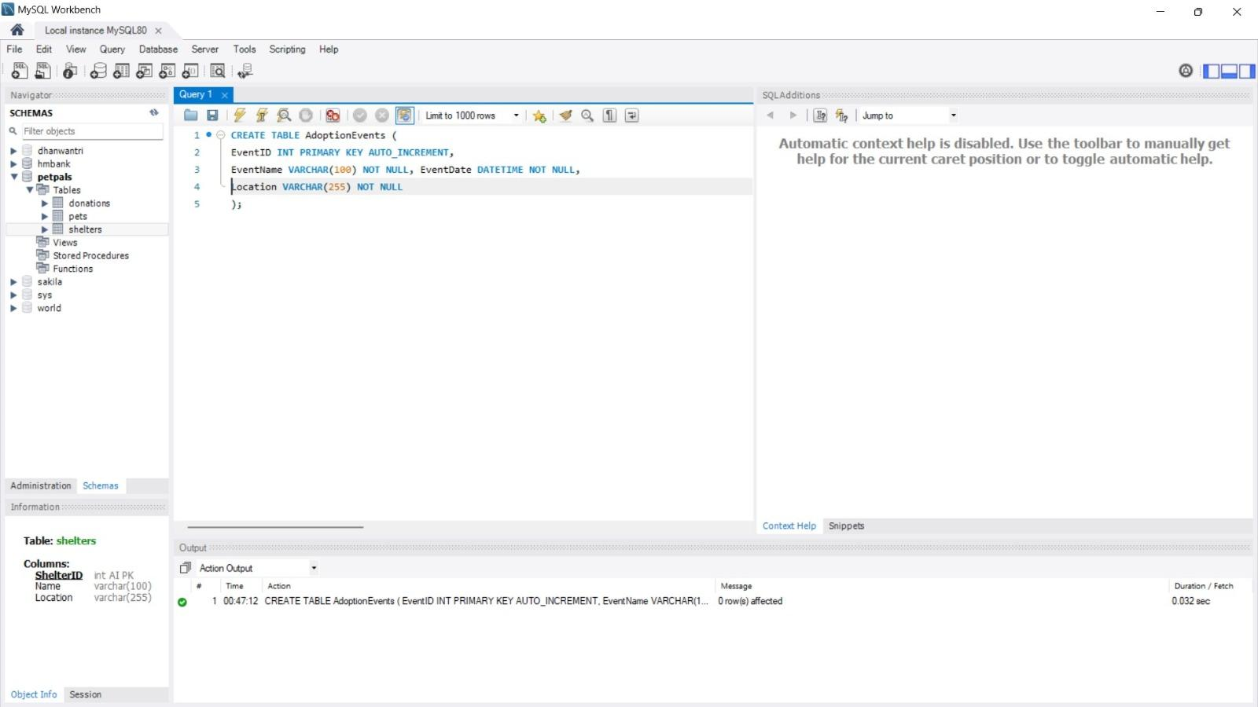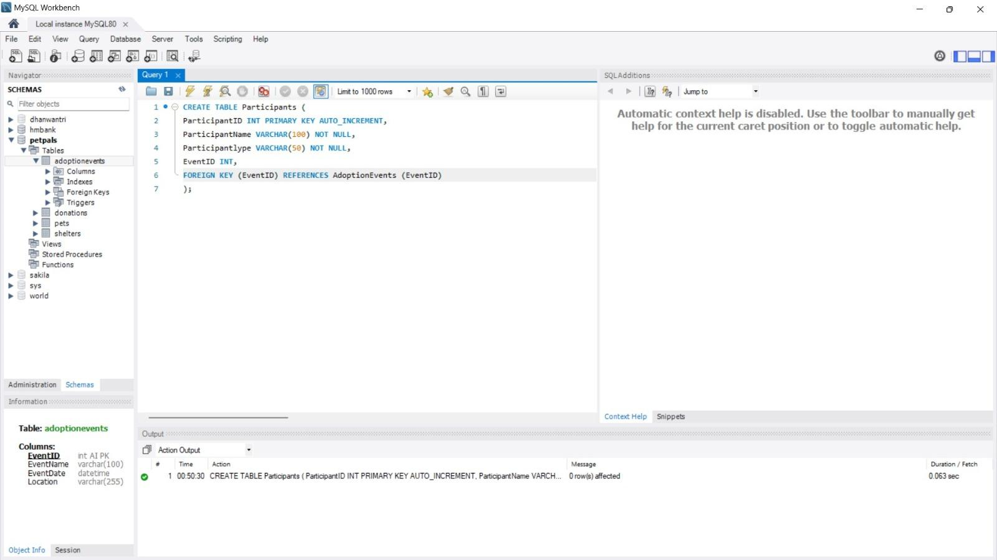

1. Define appropriate primary keys, foreign keys, and constraints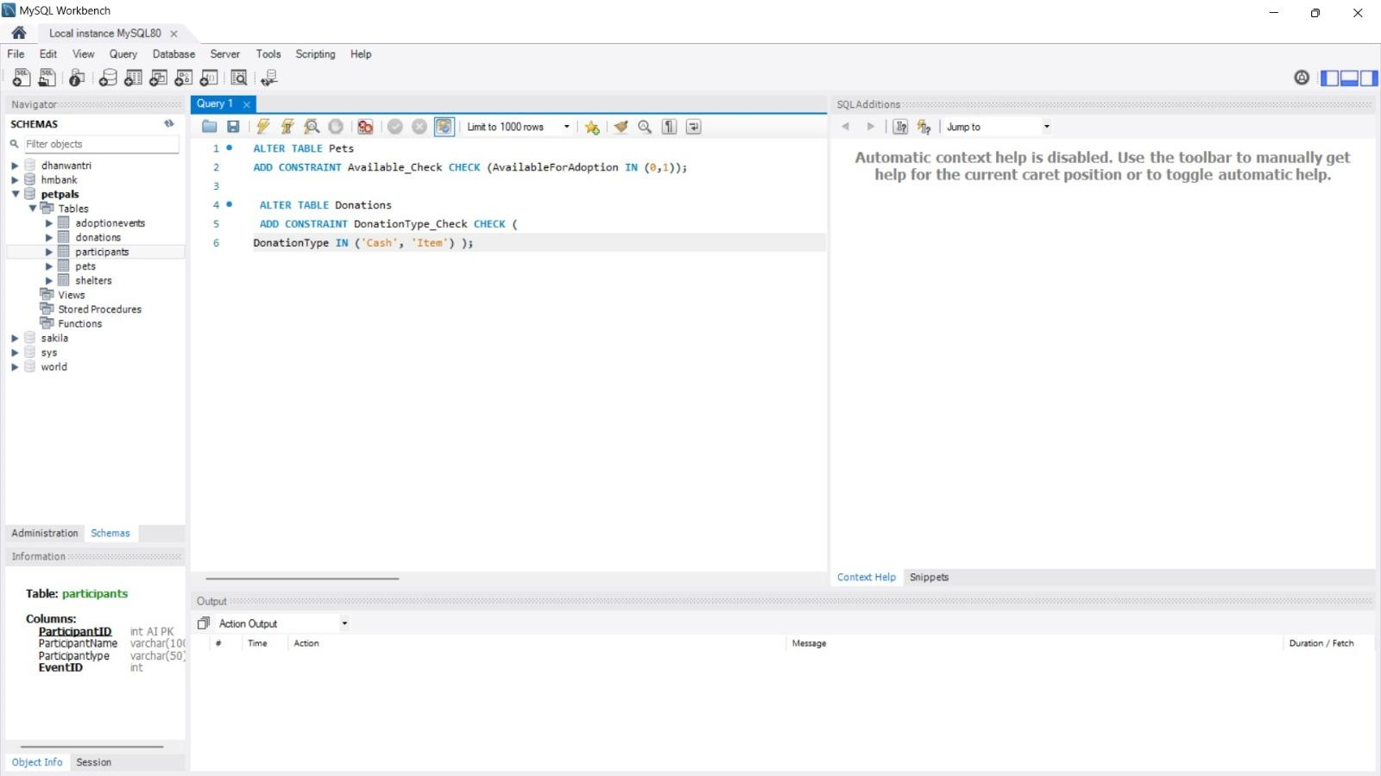
2. Write an SQL query that retrieves a list of available pets (those marked as available for adoption) from the "Pets" table. Include the pet's name, age, breed, and type in the result set. Ensure that the query filters out pets that are not available for adoption.

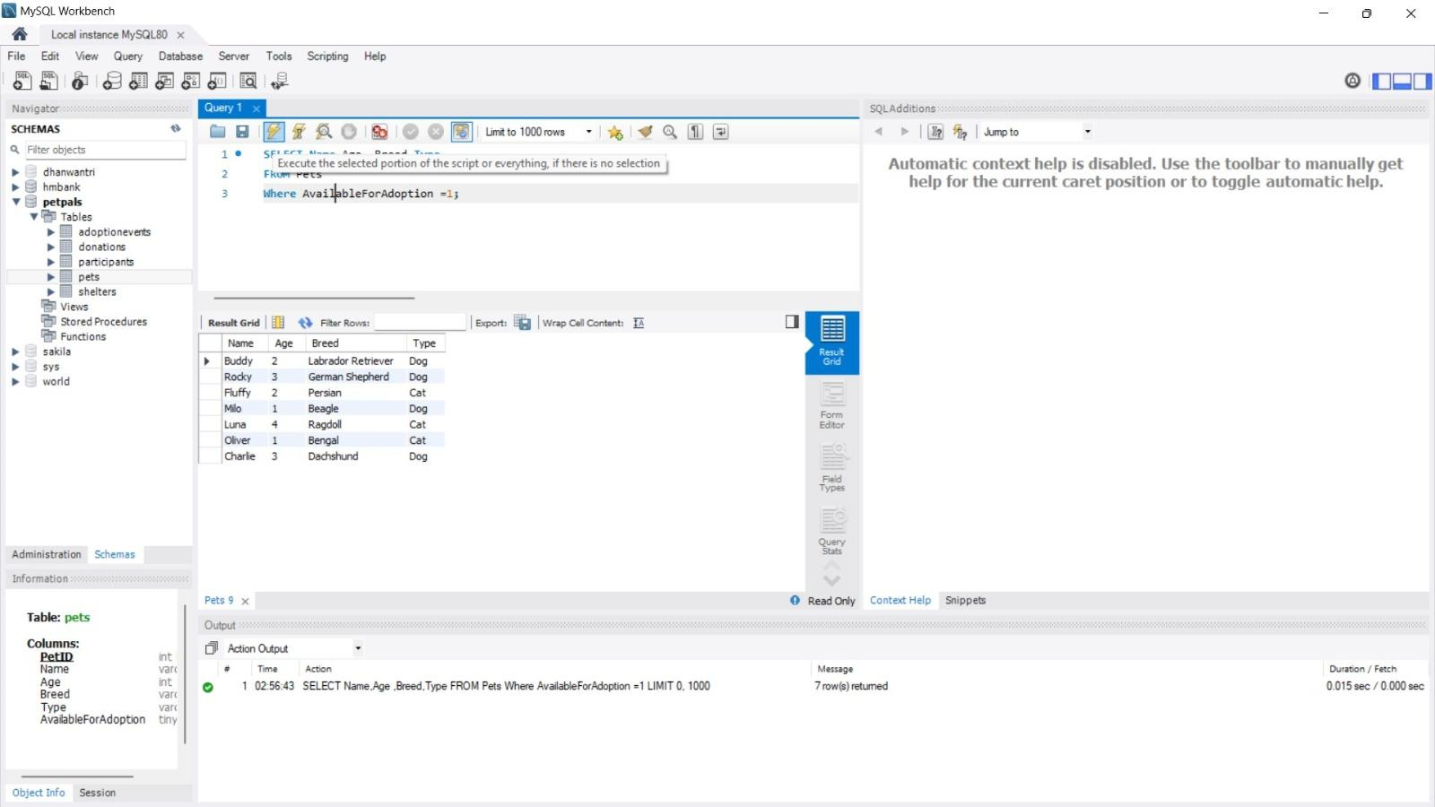

1. Write an SQL query that retrieves the names of participants (shelters and adopters) registered for a specific adoption event. Use a parameter to specify the event ID. Ensure that the query joins the necessary tables to retrieve the participant names and types.

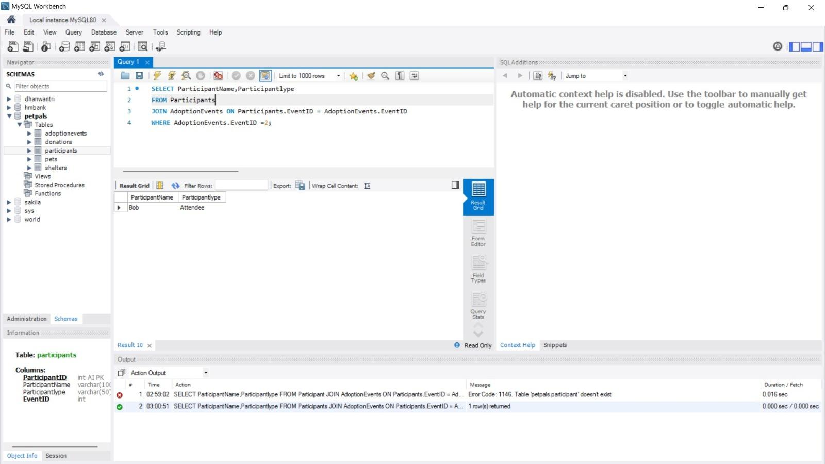

1. Create a stored procedure in SQL that allows a shelter to update its information (name and location) in the "Shelters" table. Use parameters to pass the shelter ID and the new information. Ensure that the procedure performs the update and handles potential errors, such as an invalid shelter ID.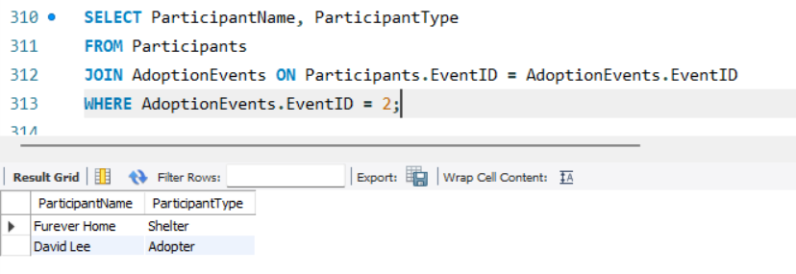
2. Write an SQL query that calculates and retrieves the total donation amount for each shelter (by shelter name) from the "Donations" table. The result should include the shelter name and the total donation amount. Ensure that the query handles cases where a shelter has received no donations.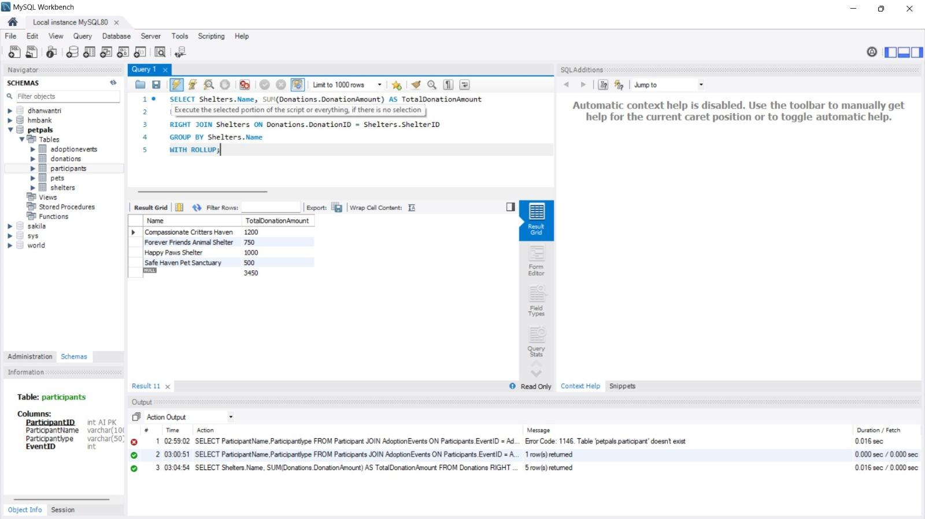
3. Write an SQL query that retrieves the names of pets from the "Pets" table that do not have an owner (i.e., where "OwnerID" is null). Include the pet's name, age, breed, and type in the result set.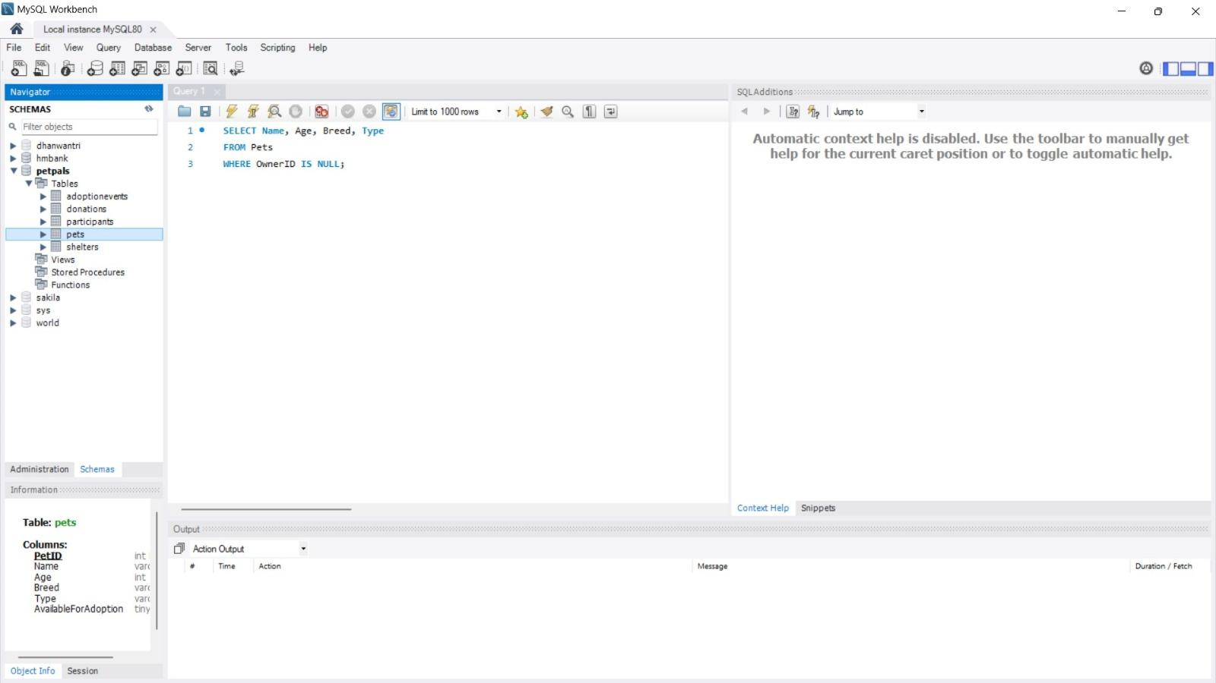
4. Write an SQL query that retrieves the total donation amount for each month and year (e.g.. January 2023) from the "Donations" table. The result should include the month-year and the corresponding total donation amount. Ensure that the query handles cases where no donations were made in a specific month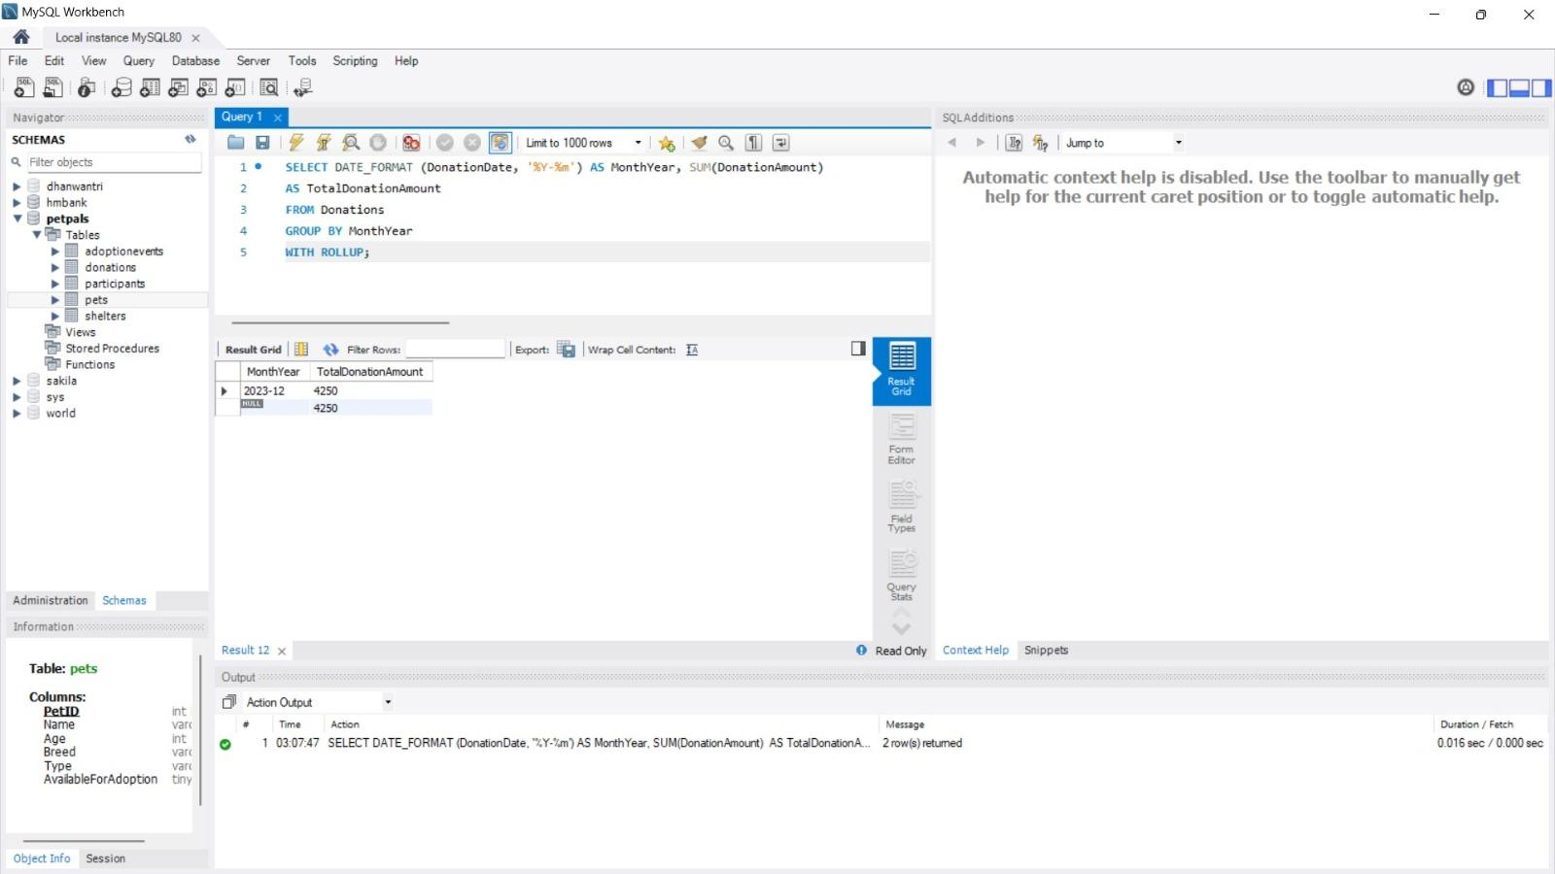
5. Retrieve a list of distinct breeds for all pets that are either aged between 1 and 3 years or older than 5 years.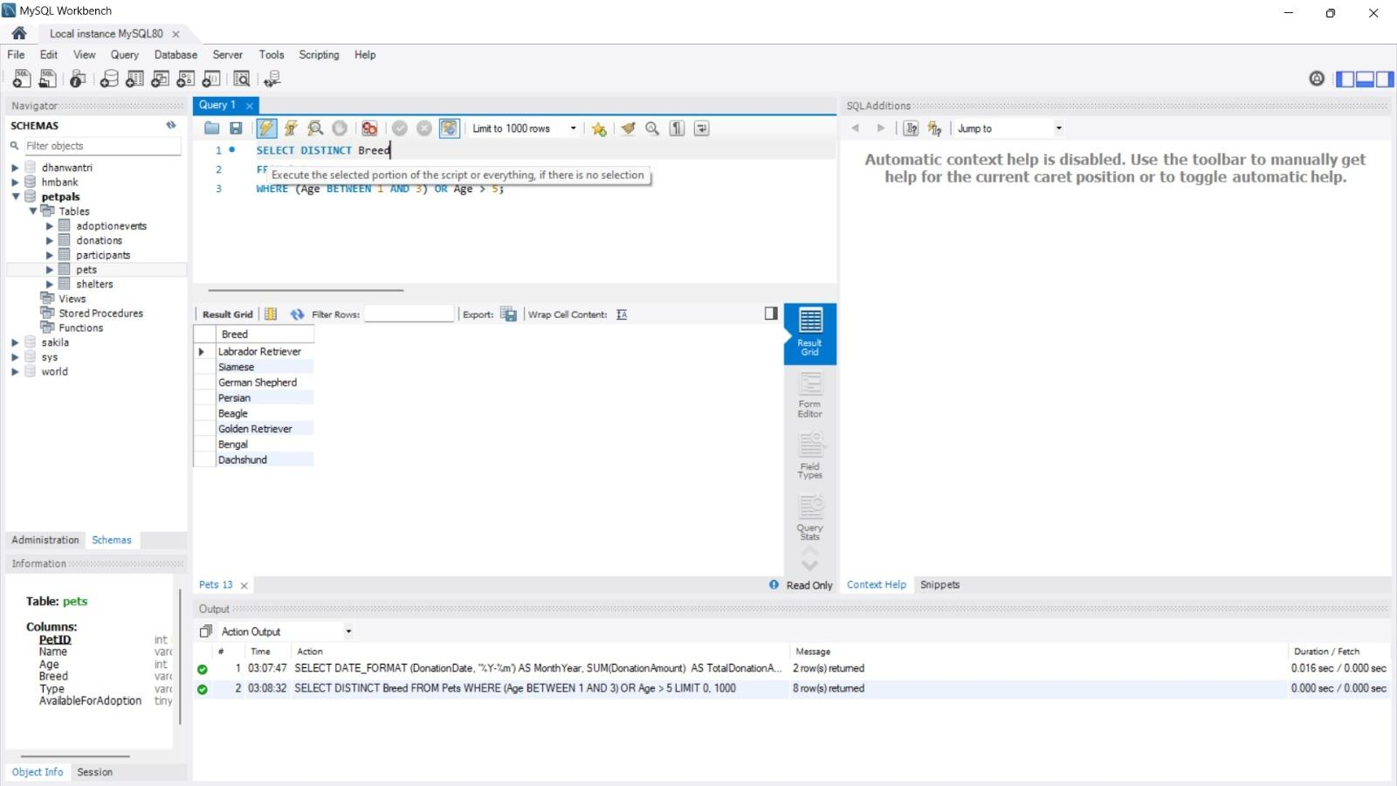
6. Retrieve a list of pets and their respective shelters where the pets are currently available for adoption.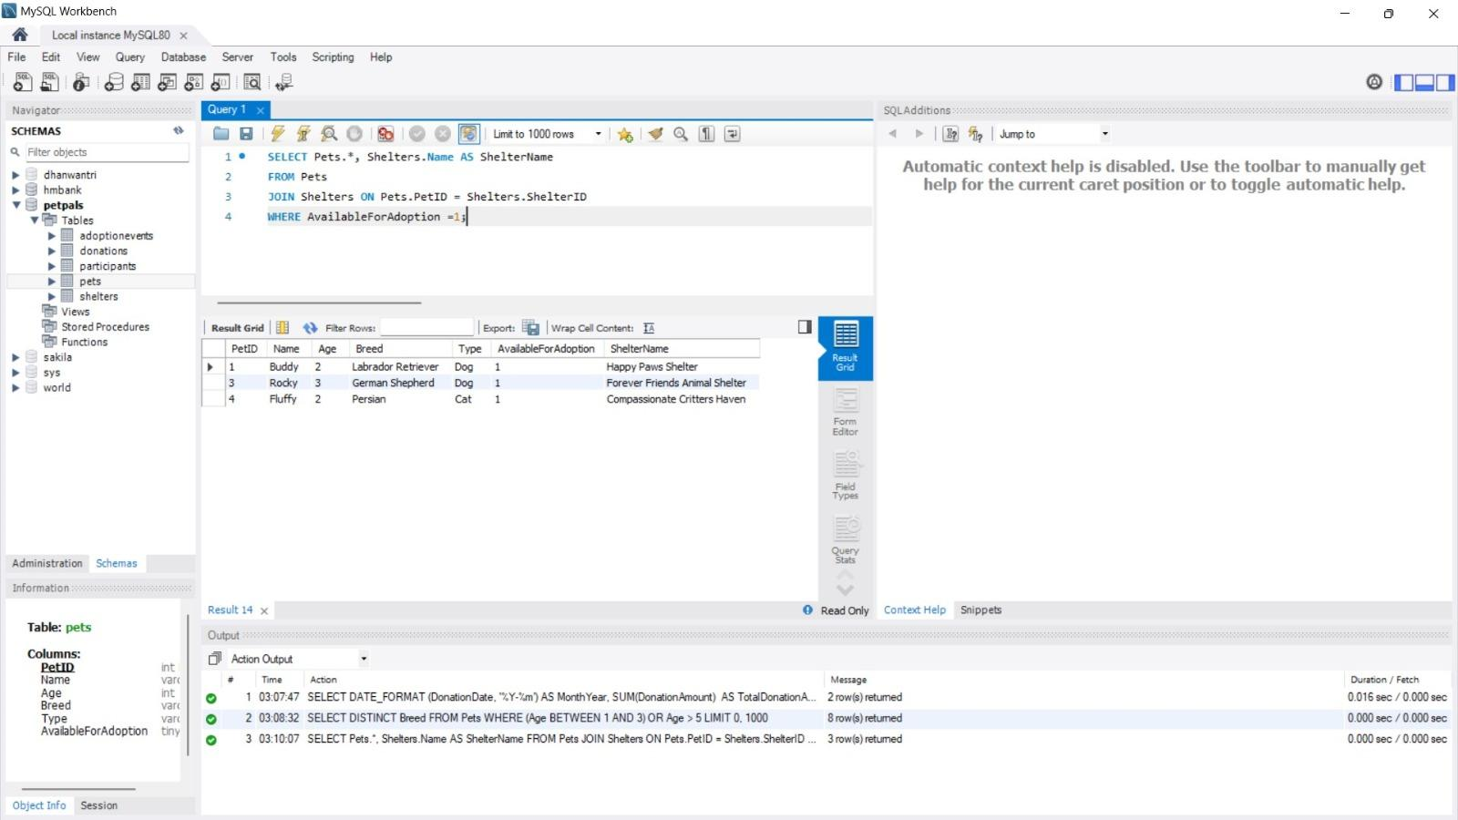
7. Find the total number of participants in events organized by shelters located in specific city. Example: City=Chennai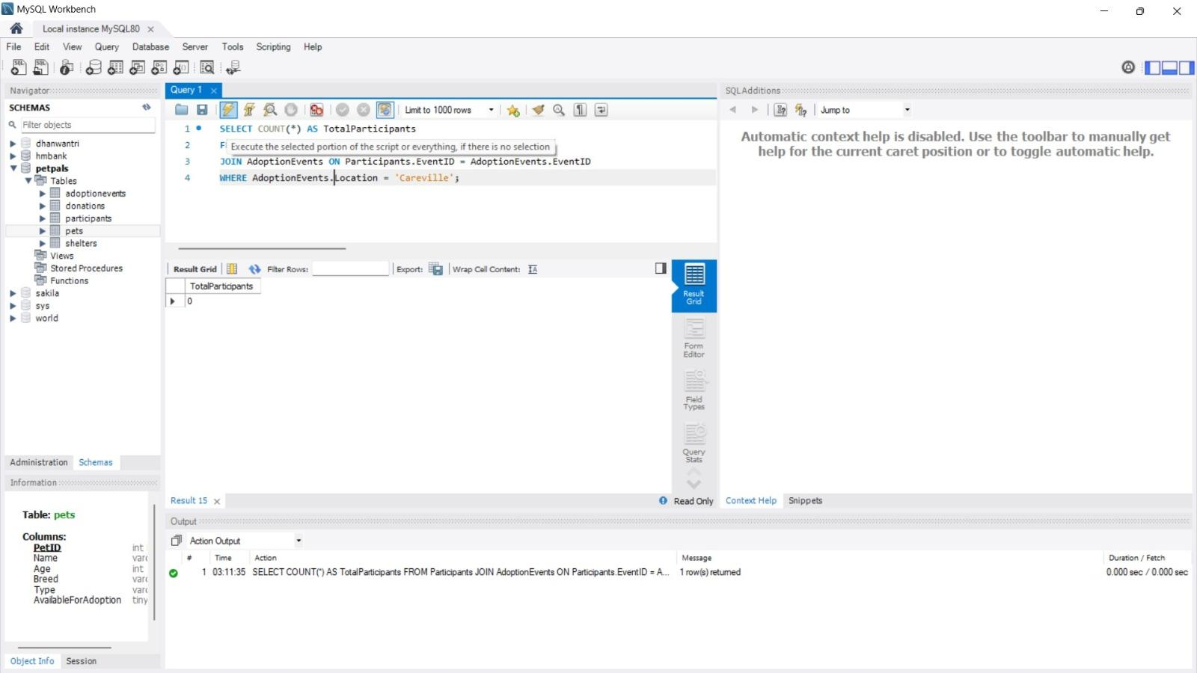
8. Retrieve a list of unique breeds for pets with ages between 1 and 5 years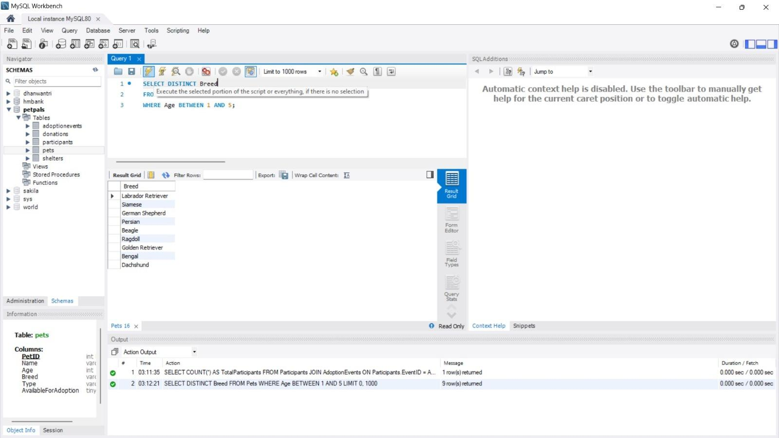
9. Find the pets that have not been adopted by selecting their information from the 'Pet' table.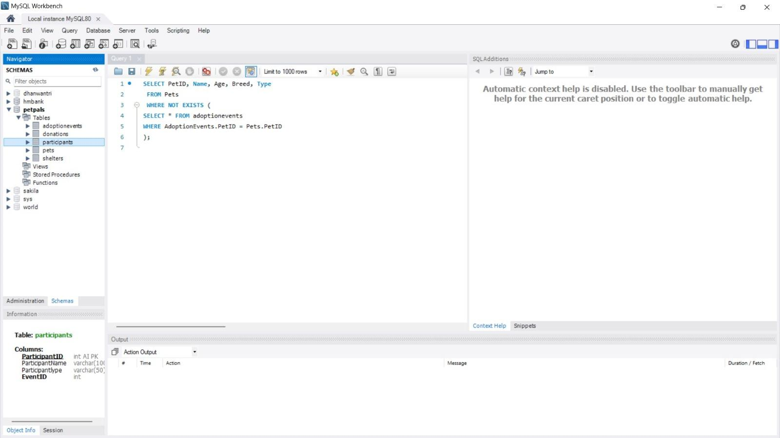
10. Retrieve the names of all adopted pets along with the adopter's name from the 'Adoption' and 'User' tables.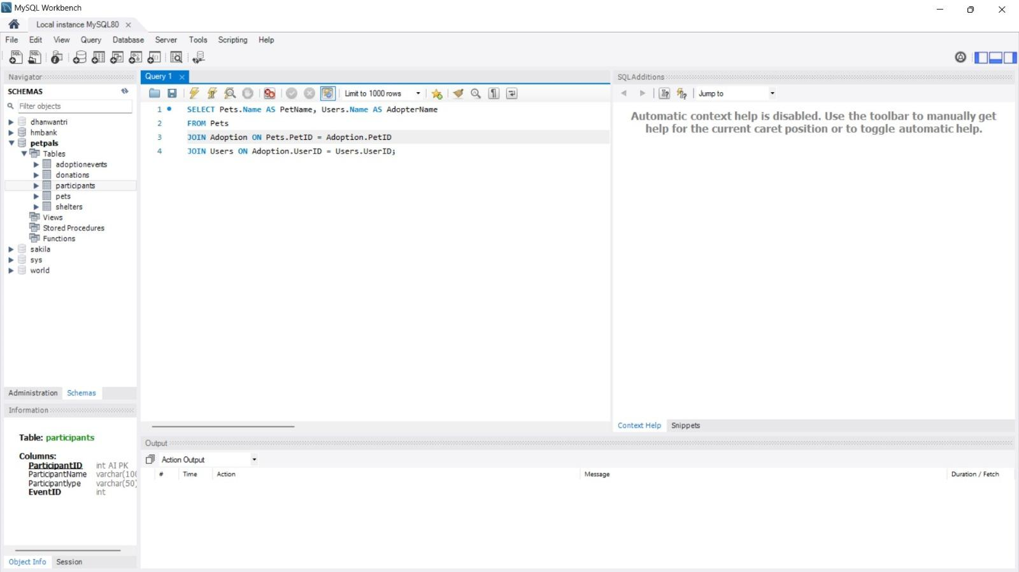
11. Retrieve a list of all shelters along with the count of pets currently available for adoption in each shelter.A screenshot of a computer

    Description automatically generated
12. Find pairs of pets from the same shelter that have the same breed.

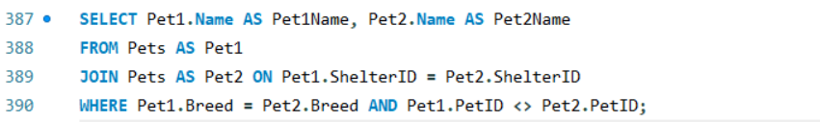

1. List all possible combinations of shelters and adoption events.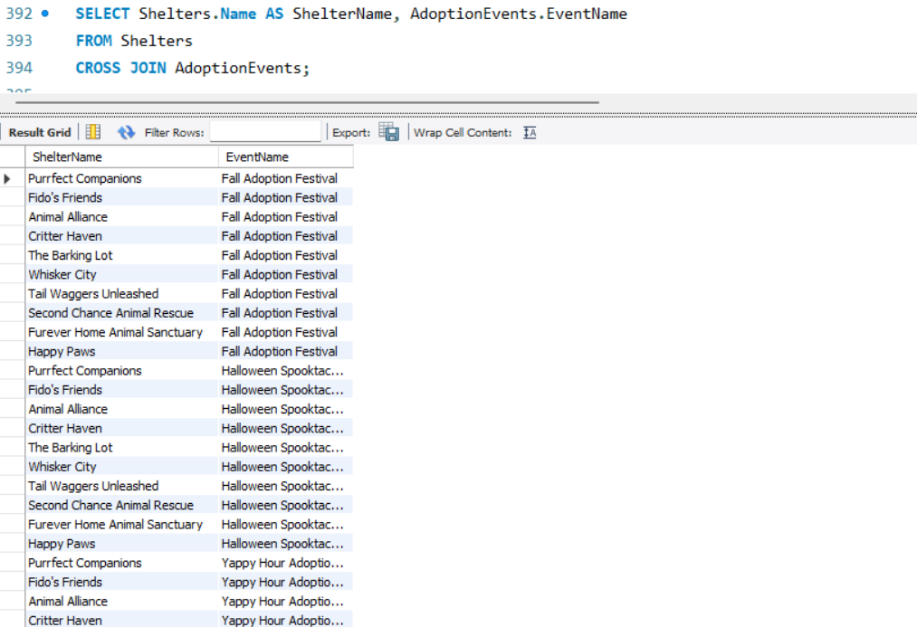
2. Determine the shelter that has the highest number of adopted pets.